# Software Requirements Specification

# PRJ566 – Fall 2024

# PRJ566 – Team No: Group 6

# Name of Project:  Capital Fin's AI-Driven Recruitment Portal

# Project Leader: Duc Long Hoang

**Last updated: 2025-01-27**

**Team Members:**

**1. Duc Long Hoang**

**2. Evan Boileau**

**3. Sebastian Perez Nakazona**

**4. Harmanjeet Singh Hara**

# TABLE OF CONTENTS

1. **Introduction/Overview - Document Information**
   1. **Document Authors**
   2. **Revision History**
   3. **Document Conventions**
   4. **Document Purpose**
   5. **Intended Audience**
   6. **Group Agreement**
2. **Project Overview**
   1. **Project Proposal**
   2. **Stakeholders and Users**
   3. **Project Scope**
   4. **Functional Requirements**
   5. **Nonfunctional Requirements**
   6. **System risks**
   7. **Operating Environment**
   8. **UI/UXD Interface Mockups**
3. **Process & Data Modeling**
   1. **UML Modeling: DFDs & Activity Diagrams**
   2. **Use Case Specification** 
      1. **Business Rules**
      2. **System Use Case Diagrams**
      3. **Use Case Description Tables**
4. **Domain Class Diagram**
5. **Database (Select either 5.1 or 5.2)**
   1. **RDBMS Artifacts**
      1. Scripts to create, populate, delete tables
      2. Data Dictionary
   2. **NoSQL Artifacts**
6. **Work breakdown Structure (WBS)**
7. **Milestones & Acceptance Criteria**
8. **Implementation Schedule (Agile/Waterfall)**
9. **Client / Faculty Sign-off**

# 1 - Introduction/Overview - Document Information

## 1.1 Document Authors

* Duc Long Hoang
* Evan Boileau
* Sebastian Perez Nakazona

## 1.2 Revision History

|  |  |
| --- | --- |
| Week 03 | Sections of this document that were completed/updated this week, example: completed/updated  1. Introduction/Overview  1.1 Document Authors (Completed)  1.2 Revision History (Completed  1.4 Document Purpose (Completed)  1.5 Intended Audience (Completed)  1.6 Group Agreement (Completed)  2.1 Project Proposal (Completed)  2.2 Stakeholders and Users (Completed)  2.3 Functional Requirements (Completed |
| Week 04 | 2.1 Project Proposal (Updated)  2.2 Stakeholders and Users (Updated)  2.3 Functional Requirements (Updated  2.4 Nonfunctional Requirements (Completed)  2.5 Project Scope (Completed) |
| Week 05 | 2.3 Functional Requirements (Completed  2.6 System Risks (completed)  2.7 Operating Environment (completed) |
| Week 06 | 2.8 UI/UXD Interface Mock-ups (completed)  3.1 UML/DFD Modeling and Data Modeling (Completed) |
| Week 07 | 3.2 Business Rules (completed)  3.3 **Use Case Specifications with corresponding interface mockups (Completed)** |
| Week 08 | Presentation (completed) |
| Week 09 | Presentation (completed) |
| Week 10 | 4. Domain Class Diagrams  5. Database |
| Week 11 | 6. Work Breakdown Structure  7. Milestone and Acceptance Criteria |
| Final |  |

## 1.3 Document Conventions

Any text in red indicates an exception or error.

Any text in blue is in-progress.

Any text highlighted in yellow is an important point.

Any text in green was recently added.

Any text *italicized* represents definitions.

Any text with ~~strike-through~~ is deleted.

## 1.4 Document Purpose

1. **Define Clear Requirements:**

* Provide a detailed description of the functional and nonfunctional requirements for the AI-Driven Recruitment Portal.
* Ensure the platform meets Capital Fin's business objectives, including streamlining recruitment, reducing HR workload, and improving hiring accuracy.

1. **Facilitate Stakeholder Communication:**

* Act as a central reference document for all stakeholders, including HR teams, developers, project sponsors, and compliance officers.
* Ensure alignment between technical teams and business stakeholders on project goals and deliverables.

1. **Ensure Compliance and Security:**

* Document adherence to data privacy regulations.
* Define security measures to protect candidate data and ensure confidentiality.

1. **Support Decision-Making:**

* Provide a basis for evaluating project scope, timelines, and resource allocation.
* Enable stakeholders to make informed decisions about feature prioritization and trade-offs.

1. **Track Progress and Changes:**

* Serve as a living document that evolves with the project, incorporating updates and feedback throughout the development lifecycle.

## 1.5 Intended Audience

**1. Development Team**

* **AI Engineer:**
  + Responsible for training and integrating the AI model for resume parsing and ranking.
  + Will use the document to understand the requirements for NLP (Natural Language Processing) and machine learning components.
* **Backend Developers:**
  + Tasked with building the server-side logic, database, and APIs.
  + Will refer to the document for database schema, API specifications, and integration requirements.
* **Frontend Developers:**
  + Responsible for designing and developing the user interface for candidates and HR teams.
  + Will use the document to understand UI/UX requirements, including wireframes and mockups.
* **DevOps Engineers:**
  + Responsible for managing CI/CD pipelines, cloud infrastructure, and deployment processes.
  + Will use the document to understand deployment requirements, scalability needs, and security configurations.

**2. HR Stakeholders**

* **HR Managers:**
  + Primary users of the platform who will post job openings and review AI-ranked candidates.
  + Will use the document to validate that the platform meets their recruitment needs and improves hiring efficiency.
* **Hiring Managers:**
  + Will rely on the platform to identify the best candidates for open positions.
  + Will use the document to understand how the AI-driven portal will streamline candidate screening and selection.

**3. Project Sponsors**

* **Capital Fin Leadership ( CEO, CFO):**
  + Responsible for approving budgets and ensuring the project aligns with business goals.
  + Will use the document to evaluate the project's feasibility, ROI, and strategic value.

## 1.6 Group Agreement

**TEAM AGREEMENT**

**Team #: Group 6**

**Project Title: AI-Driven Recruitment Portal**

**Project Time Frame: 10 Months**

**Team Members:**

* Duc Long Hoang
* Evan Boileau
* Sebastian Perez Nakazona
* Harmanjeet Singh Hara

**Team Leadership:**

Project and Tech Leader: Duc Long Hoang

* Responsible for overall project coordination, timeline management, and stakeholder communication.
* Oversees technical decisions, code quality, and integration of AI/ML components.

**Team Functions:**

* *We will share information through MS Teams, GIthub.*
* *Weekly sprint reviews.*
* ***AI Developer:****Focuses on training and integrating the AI model for resume ranking.*
* ***Backend Developer:****Builds the server-side logic, database, and APIs.*
* ***Frontend Developer:****Designs and develops the user interface for candidates and HR teams.*
* ***DevOps Engineer:****Manages CI/CD pipelines, cloud infrastructure, and deployment processes.*

**Team Meetings:**

1. **Primary Tools:**
   * **MS Teams:** For daily standups, team meetings, and quick communication.
   * **GitHub:** For version control, code reviews, and issue tracking.
   * **OneDrive:** For document sharing and collaborative editing.
2. **Meeting Schedule:**
   * **Weekly Meetings:** 1-hour sessions every Wednesday to review milestones and plan for the next week.
   * **Ad-Hoc Meetings:** Scheduled as needed to address urgent issues.

**Team Problems:**

* Lack of communication among team members
* Limited contribution to tasks or assignments

**Team Commitment**

**The undersigned members agree to work together on the project until the end of the PRJ666 next Semester. They recognize that as a team and individually they are responsible for the quality of all deliverables.**

**Name Date**

|  |  |
| --- | --- |
| Long | 2025-01-27 |
|  |  |
|  |  |
|  |  |

ShapeShapeShapeShapeShapeShapeShapeShape

# 2 - Project Overview

## 2.1 Project Proposal

Project Background

Capital Fin, a growing financial services company, is expanding its operations to meet increasing market demands. This growth requires a significant workforce expansion, resulting in a high volume of job applications. The current manual recruitment process is inefficient, time-consuming, and prone to human error, leading to delays in hiring and potential oversights in identifying top talent.

To address these challenges, Capital Fin is developing an AI-driven recruitment portal. This platform will automate resume screening, improve hiring efficiency, and enhance the candidate experience by leveraging AI to analyze and rank resumes based on job requirements.

**Problem Statement**

|  |  |
| --- | --- |
| The Problem of: | Manual recruitment inefficiencies, including slow resume screening, subjective candidate evaluation, and high HR workload. |
| Affects: | HR Teams, Hiring Managers, and Candidates. |
| The impact of which is: | - Delays in hiring due to manual screening processes.  - Increased HR operational costs.  - Potential loss of top talent due to slow response times.  - Inconsistent hiring decisions influenced by human bias. |
| A successful solution would: | - Automate resume screening with AI to improve hiring accuracy and efficiency.  - Reduce time-to-hire by at least 40%.  - Provide a bias-free ranking system for candidates based on job descriptions.  - Offer a real-time dashboard for HR teams and candidates to track hiring progress. |

**Product Vision**

|  |  |
| --- | --- |
| For | HR Teams, Hiring Managers, and Recruitment Decision-Makers at Capital Fin. |
| Who | Need an efficient, automated, and bias-free hiring solution that streamlines resume screening and candidate selection. |
| The Product Name | Capital Fin's AI-Driven Recruitment Portal |
| That | - Automates job posting, resume screening, and candidate ranking using AI. - Reduces manual workload for HR teams and hiring managers. - Provides real-time analytics on hiring efficiency and candidate performance. - Ensures compliance with data privacy regulations. |
| Unlike | Traditional Applicant Tracking Systems (ATS) that rely on keyword-based filtering with minimal AI intelligence. |
| Our product | - Uses explainable AI for transparency in candidate ranking.  - Enhances hiring accuracy and efficiency through data-driven insights.  - Provides mobile-friendly access for both HR teams and candidates.  - Offers seamless integration with Capital Fin’s HR systems. |

## 2.2 Stakeholders and Users

|  |  |
| --- | --- |
| Stakeholder Name/Identifier | Category |
| HR Managers | Primary Users. Responsible for job postings, reviewing AI-ranked candidates, and final hiring decisions. |
| Candidates | End Users. Apply for job positions and track application progress through the platform. |
| Compliance Officers | Regulatory Oversight. Ensure that the platform adheres to industry regulations and data privacy laws (e.g., GDPR, CCPA). |
| Developers | Technical Team. Build and maintain the AI-driven recruitment portal, ensuring seamless integration with existing HR systems. |
| Cost Accountant | Business User. Assesses the cost-effectiveness of the recruitment platform and its impact on HR expenses. |
| Project Sponsor (CEO) | Administration. Provide funding and strategic direction for the project. |

## 2.3 Functional Requirements

1. Job Posting Management:

* HR can create/edit/delete job listings.
* Auto-publish to career page.

1. AI Resume Screening:

* Parse resumes, match keywords to job descriptions.
* Rank candidates (1–5 stars).

1. Candidate Dashboard:

* Apply for jobs, track application status.
* Mobile-friendly interface.

1. HR Analytics:

* Generate reports (e.g., time-to-hire, diversity metrics).

## 2.4 Nonfunctional Requirements

1. **Performance**

* The system should handle a **minimum of 1,000 concurrent users** without significant performance degradation.
* Response time for user actions must not exceed **2 seconds** under normal conditions.

1. **Security**

* Data must be **encrypted** in transit and at rest.
* The system must follow **OWASP security best practices** to prevent vulnerabilities such as **SQL injection and cross-site scripting**.

1. **Scalability**

* The system should be able to **scale horizontally** to accommodate increased load.
* Cloud deployment should be **supported to enhance scalability**.

1. **Maintainability**

* The codebase should follow **industry best practices** and be **well-documented**.
* Regular updates and patches must be applied without disrupting ongoing operations.

1. **Usability**

* The system must comply with **accessibility standards** (e.g., WCAG 2.1) to support users with disabilities.
* A **comprehensive user manual** should be provided for onboarding new users.

1. **Availability and Reliability**

* The system should have an **uptime of 99.9% or higher**.
* **Automated backups** must be performed daily to prevent data loss.

## 2.5 Project Scope

The primary objective of this project is to develop a robust and user-friendly software solution that meets the specific needs outlined by stakeholders. The system will provide seamless integration of essential functionalities, ensuring efficiency, reliability, and scalability. Key focus areas include enhancing user experience, automating repetitive tasks, and ensuring compliance with industry standards. The project aims to deliver a functional, scalable, and maintainable system within the given time frame and budget constraints.

## 2.6 System Risks

|  |  |
| --- | --- |
| **Risk** | **Response** |
| Data Privacy and Security Breaches | Implement various security measures and keep code modular in order to reduce complexity and increase security |
| AI Bias in Resume Screening | Train AI with diverse datasets, continuously monitor bias, and incorporate explainable AI (XAI) methodologies. |
| System Downtime and Performance Issues | Deploy auto-scaling cloud infrastructure, conduct load testing, and ensure a 99.9% uptime SLA. |
| Integration Challenges with HR Systems | Use standardized APIs and middleware solutions to ensure seamless data exchange with HR software. |
| Legal and Compliance Risks | Conduct legal reviews, integrate compliance checks, and update policies regularly to meet employment and data protection laws. |
| User Adoption Resistance | Provide comprehensive training sessions, an intuitive user interface, and customer support. |
| AI Model Accuracy and Reliability | Continuously improve AI models through feedback loops, real-world testing, and dataset updates. |
| Budget Constraints | Establish contingency funds and prioritize features based on critical business needs. |

## 2.7 Operating Environment

The AI-Driven Recruitment Portal will be deployed in a scalable and secure cloud environment to ensure high availability and efficiency. The system’s operating environment includes the following:

1. Hardware Requirements

* Server Infrastructure: Cloud-based (AWS, Azure, or Google Cloud)
* Database Server: NoSQL (MongoDB, Weaviate) and RDBMS (PostgreSQL/MySQL)
* Load Balancer: Cloud-based for auto-scaling and high availability
* Client Devices: Desktop, laptop, mobile (iOS and Android)
* Minimum Client Specs:
  + 2 GHz Dual-Core Processor
  + 8 GB RAM
  + Stable Internet Connection

2. Software Requirements

* Operating System: Linux-based (Ubuntu 20.04 LTS, AWS AMI)
* Backend Frameworks: Node.js (Express.js), Python (Flask for AI models)
* Frontend Frameworks: React.js with Next.js for SSR
* AI/ML Stack: Hugging Face Transformers, TensorFlow, OpenAI GPT for NLP-based resume screening
* Cloud Services:
  + Storage: AWS S3, Google Cloud Storage
  + Compute: AWS EC2, Google Cloud Compute Engine
  + Security: AWS IAM, Azure Security Center
* APIs & Integrations: RESTful APIs for HR system connectivity, OAuth2 for authentication
* Development Tools:
  + CI/CD: GitHub Actions, Docker, Kubernetes
  + Monitoring: Prometheus, Grafana, Datadog

3. Networking and Security

* Encryption: AES-256 encryption for data at rest, TLS 1.2+ for data in transit
* Firewall Protection: Configurable firewall to block unauthorized access
* Authentication: Multi-Factor Authentication (MFA), Role-Based Access Control (RBAC)
* Data Compliance: Adherence to GDPR, CCPA, ISO 27001 standards

4. Deployment Model

* Development Environment: Local setup with Docker containers
* Testing/Staging Environment: Cloud-hosted testing servers
* Production Environment: Deployed on AWS, Azure, or GCP with auto-scaling
* High Availability: Redundant architecture with automated failover mechanisms

## 2.8 UI/UXD Interface Mock-ups

**Career Page:**

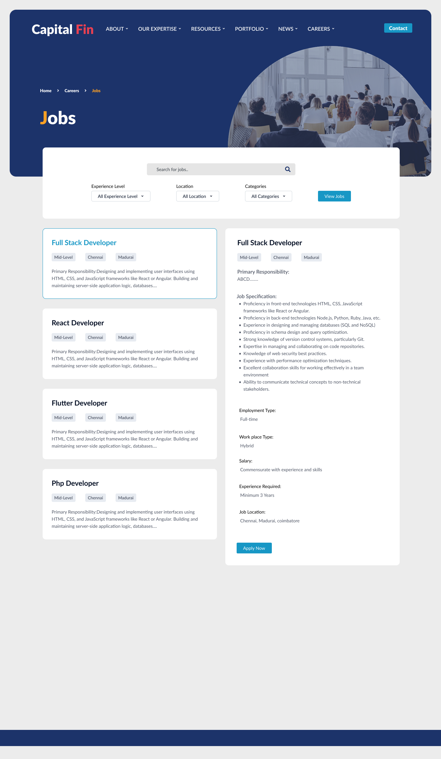

**Login page:**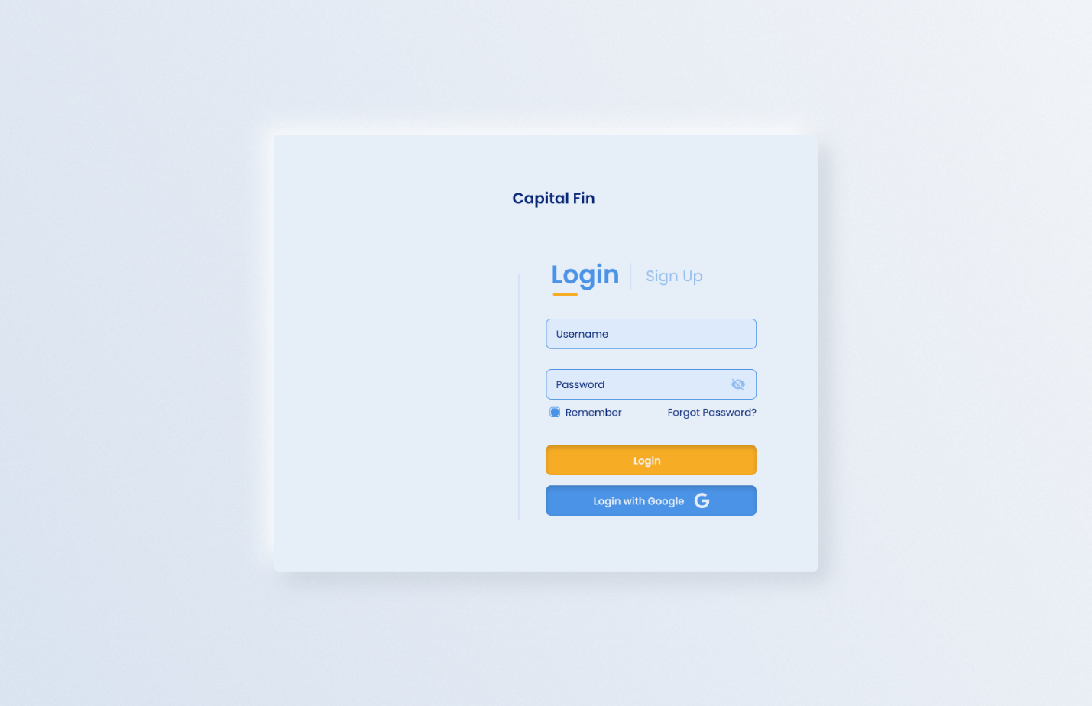

**Human Resource Dashboard:**

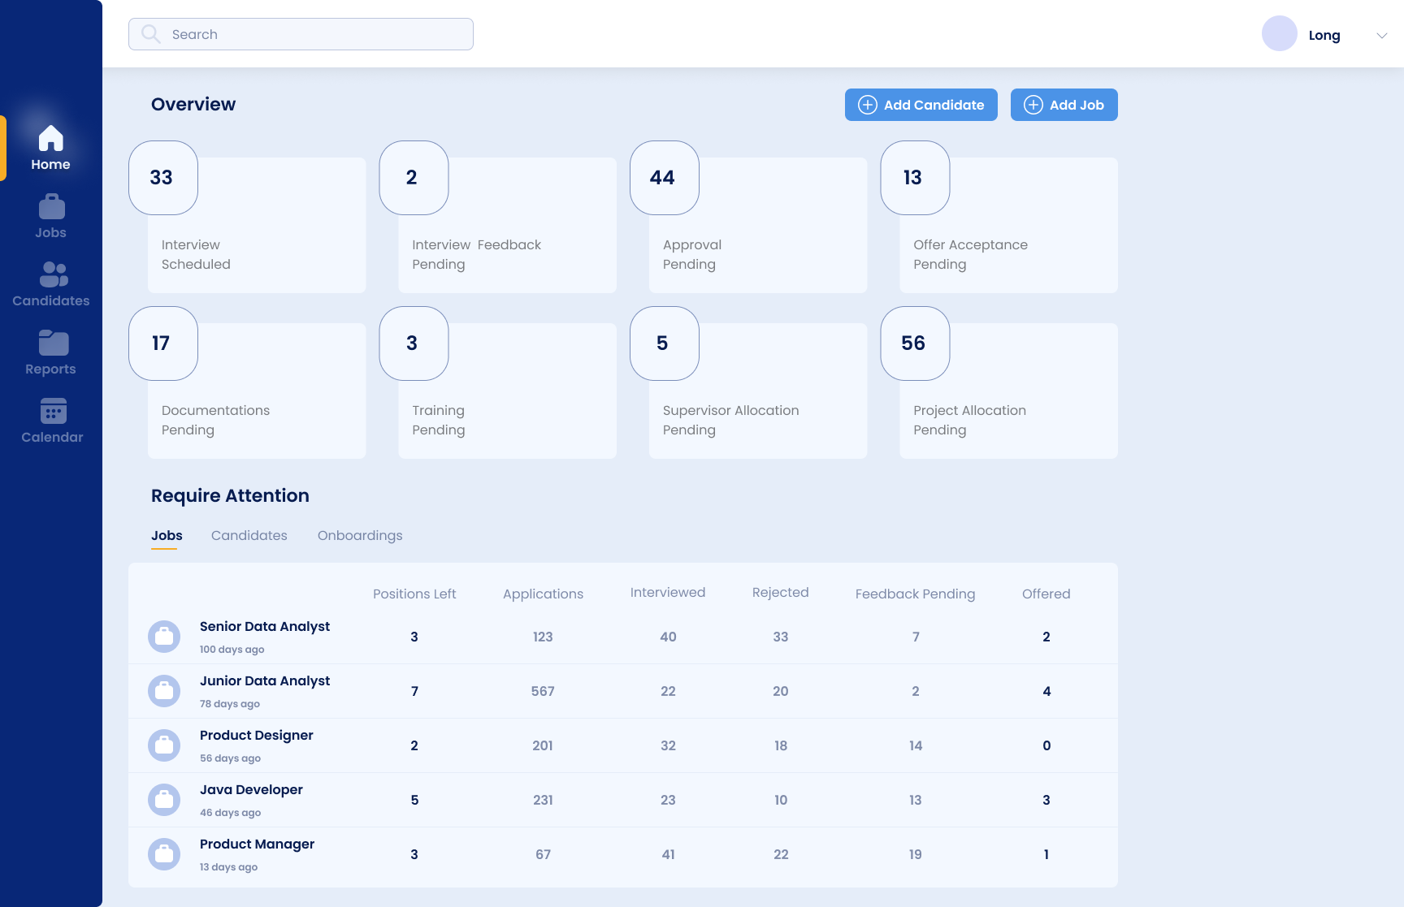

**Candidate List:**

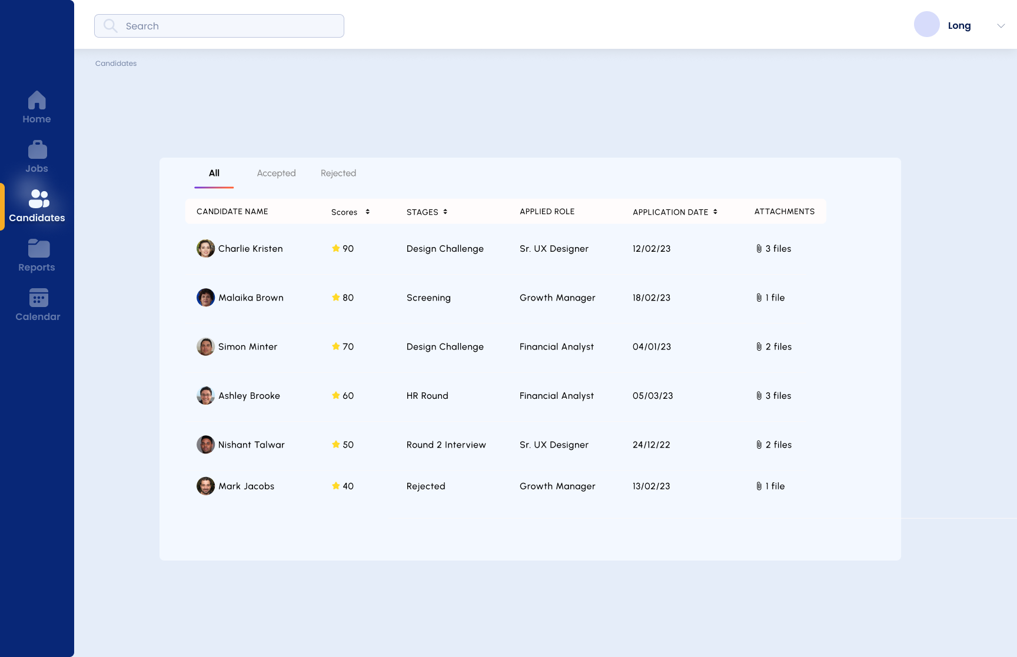

**Candidate Profile Score:** 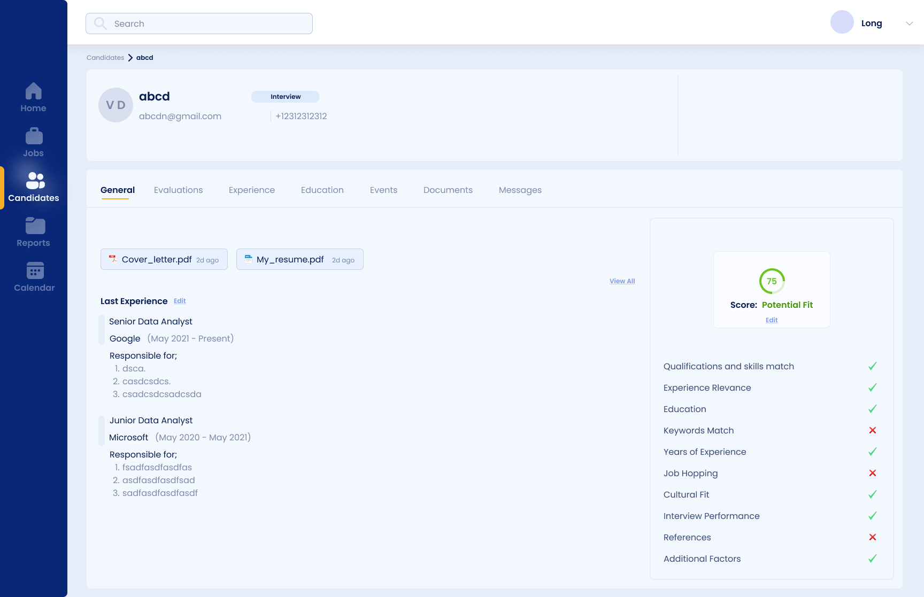

# Process and Data Modeling

## **3.1 UML/DFD Modeling and Data Modeling**

### Activity Diagrams

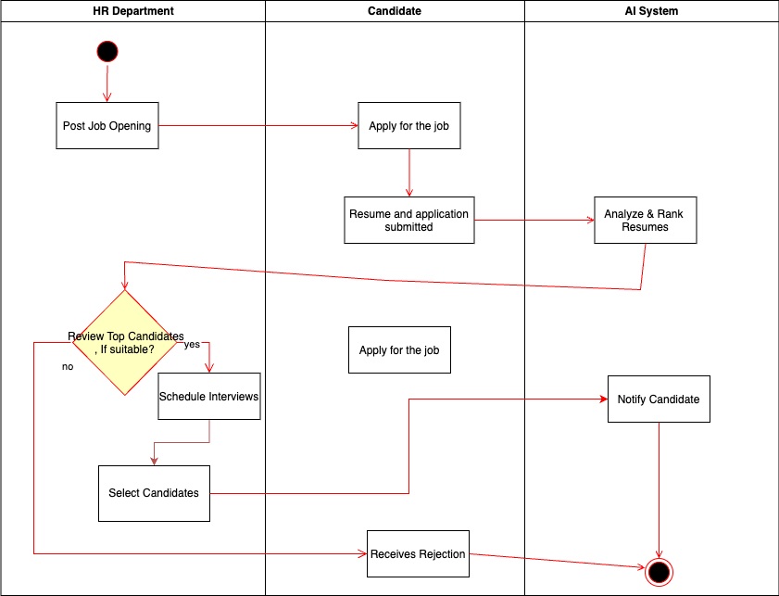

### Data Flow diagram

## **3.2 Business Rules**

|  |  |  |
| --- | --- | --- |
| Business Rule Number | Business Rule Description | Related UC |
| BR01 | HR users must provide a valid company email, password, and role to register for the portal. | UC01 |
| BR02 | Candidates must submit a resume file (PDF, DOCX) and contact details to apply for a job listing. | UC02 |
| BR03 | Job postings must include a title, description, requirements, and application deadline before publishing. | UC03 |
| BR04 | The AI system must rank candidates based on job requirements and assign a score between 1 and 5 stars. | UC04 |
| BR05 | Candidate data (e.g., resumes, contact info) must be encrypted at rest and in transit to ensure privacy. | UC05 |
| BR06 | HR users can only view candidate details and rankings for job postings they created or are assigned to. | UC06 |
| BR07 | The system must generate hiring analytics reports (e.g., time-to-hire) within 10 seconds of request. | UC07 |
| BR08 | Job postings cannot be edited after the application deadline has passed. | UC08 |
| BR09 | Candidates can only apply to a job posting once unless the posting is reopened by HR. | UC09 |
| BR10 | The system must comply with GDPR and CCPA by allowing candidates to request data deletion. | UC10 |

## **3.3 Use Case Specifications with corresponding interface mockups:**

**Each use case needs to have the following:**

UC01 - User Registration

* + Business Rules: BR01
  + System Use Case Diagram:

* + Corresponding Interface Mockup:

UC02 - Candidate Job Application

* + Business Rules: BR02, BR09
  + System Use Case Diagram:

* + Corresponding Interface Mockup:

UC03 - Create/Edit Job Posting

* + Business Rules: BR03, BR08
  + System Use Case Diagram:

* + Corresponding Interface Mockup:

UC04 - AI Resume Screening and Ranking

* + Business Rules: BR04
  + System Use Case Diagram:

* + Corresponding Interface Mockup:

UC05 - Generate HR Analytics

* + Business Rules: BR07
  + System Use Case Diagram:

* + Corresponding Interface Mockup:

# Domain Class Diagrams

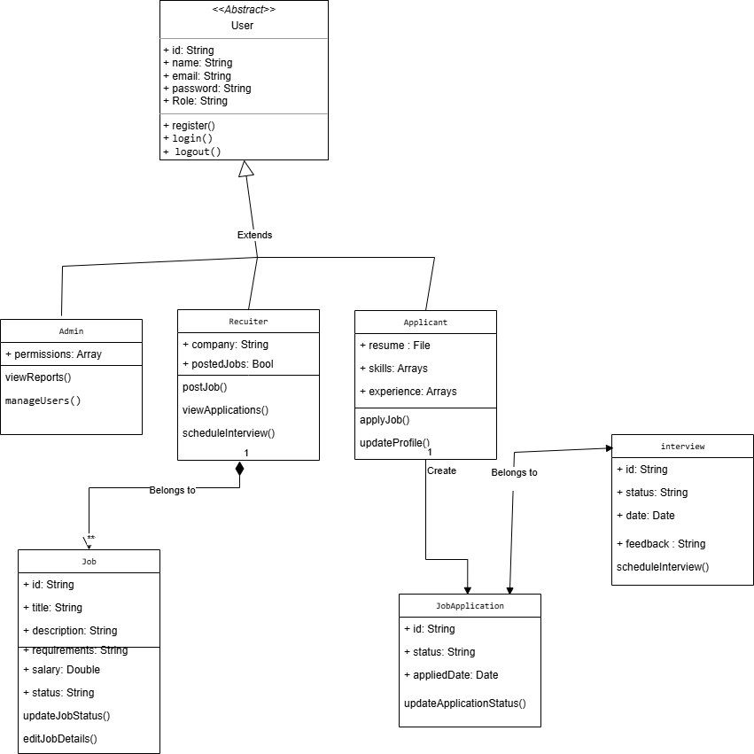

# Database

**CREATE TABLE users (**

**id UUID PRIMARY KEY DEFAULT gen_random_uuid(),**

**name VARCHAR(100) NOT NULL,**

**email VARCHAR(255) UNIQUE NOT NULL,**

**password_hash TEXT NOT NULL,**

**role VARCHAR(50) CHECK (role IN ('applicant', 'recruiter', 'admin')) NOT NULL,**

**created_at TIMESTAMP DEFAULT NOW()**

**);**

**CREATE TABLE applicants (**

**id UUID PRIMARY KEY REFERENCES users(id) ON DELETE CASCADE,**

**phone VARCHAR(20),**

**linkedin VARCHAR(255),**

**skills TEXT[],**

**experience TEXT**

**);**

**CREATE TABLE recruiters (**

**id UUID PRIMARY KEY REFERENCES users(id) ON DELETE CASCADE,**

**company VARCHAR(255),**

**company_website VARCHAR(255)**

**);**

**CREATE TABLE jobs (**

**id UUID PRIMARY KEY DEFAULT gen_random_uuid(),**

**recruiter_id UUID REFERENCES recruiters(id) ON DELETE SET NULL,**

**title VARCHAR(255) NOT NULL,**

**status VARCHAR(50) CHECK (status IN ('open', 'closed', 'filled')) DEFAULT 'open',**

**salary_range VARCHAR(100),**

**created_at TIMESTAMP DEFAULT NOW(),**

**updated_at TIMESTAMP DEFAULT NOW()**

**);**

**CREATE TABLE job_applications (**

**id UUID PRIMARY KEY DEFAULT gen_random_uuid(),**

**applicant_id UUID REFERENCES applicants(id) ON DELETE CASCADE,**

**job_id UUID REFERENCES jobs(id) ON DELETE CASCADE,**

**status VARCHAR(50) CHECK (status IN ('pending', 'interview_scheduled', 'rejected', 'hired')) DEFAULT 'pending',**

**applied_at TIMESTAMP DEFAULT NOW()**

**);**

**CREATE TABLE interviews (**

**id UUID PRIMARY KEY DEFAULT gen_random_uuid(),**

**application_id UUID REFERENCES job_applications(id) ON DELETE CASCADE,**

**interview_date TIMESTAMP NOT NULL,**

**status VARCHAR(50) CHECK (status IN ('scheduled', 'completed', 'cancelled')),**

**feedback TEXT**

**);**

**{**

**"classes": [**

**{**

**"class": "Resume",**

**"vectorizer": "text2vec-openai",**

**"properties": [**

**{ "name": "applicant_id", "dataType": ["uuid"] },**

**{ "name": "text", "dataType": ["text"] },**

**{ "name": "embedding", "dataType": ["vector"] }**

**]**

**},**

**{**

**"class": "JobDescription",**

**"vectorizer": "text2vec-openai",**

**"properties": [**

**{ "name": "job_id", "dataType": ["uuid"] },**

**{ "name": "text", "dataType": ["text"] },**

**{ "name": "embedding", "dataType": ["vector"] }**

**]**

**}**

**]**

**}**

# Work Breakdown Structure (WBS)

## 

## Work Breakdown Structure

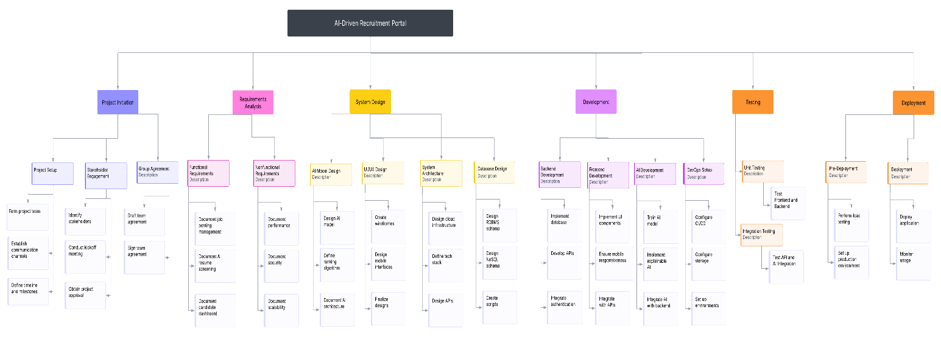

# Milestones and Acceptance Criteria

**Milestone 1: Project Initiation Complete**

* **Definition**: Establish the project foundation, including team setup, stakeholder engagement, and initial planning.
* **Acceptance Criteria**:
  + Team roles assigned and agreement signed by all members by 2025-01-27.
  + MS Teams, GitHub, and OneDrive set up; first team meeting held.
  + Kickoff meeting conducted; project approval obtained from CEO.
  + Project timeline and milestones documented in SRS.
* **Target Date**: 2025-02-05

**Milestone 2: Requirements Analysis Complete**

* **Definition**: Finalize functional and nonfunctional requirements with stakeholder validation.
* **Acceptance Criteria**:
  + Functional requirements (job posting, AI screening, candidate dashboard, HR analytics) documented.
  + Nonfunctional requirements (performance, security, scalability, usability, availability) documented.
  + Requirements validated by HR stakeholders; SRS updated and approved.
  + Requirements traceability matrix created.
* **Target Date**: 2025-02-26

**Milestone 3: System Design Complete**

* **Definition**: Complete system architecture, database, UI/UX, AI model, and process modeling.
* **Acceptance Criteria**:
  + Cloud infrastructure and tech stack documented.
  + RDBMS and NoSQL schemas designed; scripts and data dictionary completed.
  + UI/UX mockups validated by HR stakeholders; mobile-friendly design confirmed.
  + AI model architecture and ranking algorithm defined with XAI approach.
  + UML diagrams, use cases, business rules, and domain class diagrams completed.
* **Target Date**: 2025-04-09

**Milestone 4: Development Complete**

* **Definition**: Build and integrate backend, frontend, AI model, security, and DevOps components.
* **Acceptance Criteria**:
  + Backend APIs, database, and authentication implemented and tested.
  + Frontend UI components implemented, mobile-responsive, and integrated with APIs.
  + AI model trained (85% accuracy), integrated, and provides 1–5 star rankings.
  + Security features (encryption, TLS, OWASP compliance, MFA, RBAC) implemented.
  + CI/CD pipelines, monitoring, and cloud environments set up.
* **Target Date**: 2025-07-02

**Milestone 5: Testing Complete**

* **Definition**: Ensure the system meets all requirements through testing and user validation.
* **Acceptance Criteria**:
  + Unit tests pass 90% (backend, AI, frontend).
  + Integration tests confirm seamless API, AI, and database connectivity.
  + System tests verify end-to-end functionality, performance (1,000 users, <2s), and security.
  + UAT completed with HR stakeholder sign-off; 40% time-to-hire reduction confirmed.
* **Target Date**: 2025-08-27

**Milestone 6: Deployment Complete**

* **Definition**: Deploy the system to production and ensure it’s operational.
* **Acceptance Criteria**:
  + Load testing confirms scalability; production environment set up with backups.
  + Application deployed with zero downtime; 99.9% uptime in first 48 hours.
  + User manual created; training sessions conducted (80% attendance); support resources available.
* **Target Date**: 2025-09-24

**Milestone 7: Post-Deployment Review**

* **Definition**: Monitor the system, resolve issues, and plan for improvements.
* **Acceptance Criteria**:
  + System maintains 99.9% uptime and <2s response time for 30 days.
  + Critical issues resolved within 48 hours without downtime.
  + User feedback collected (50 responses, 80% satisfaction).
  + AI update plan and feature enhancement backlog created.
* **Target Date**: 2025-10-29

# Implementation Schedule

Implementation Schedule using MS Project (Waterfall)

OR

Product Backlog (Agile-Scrum)

<https://github.com/users/duclongbox/projects/2/views/1>

# Client / Faculty Sign-off

**Date: __2025-04-07____________________**

X .

Name of Client/Rep/Professor